COSC 4P14
Lab 2
1.
- What is the whois database?
The whois database is a database containing the contact and registration information for domain names, such as server name and IP address.
- Use various whois databases on the Internet to obtain the names of two DNS servers. Indicate which whois databases you used.
Using the whois lookup tool available on www.whois.net, I found the names of two DNS servers:
- ns1.google.com (google.com)
- a.ns.facebook.com (facebook.com)

- Use nslookup on your local host to send DNS queries to three DNS servers: your local DNSserver and the two DNS servers you found in part (b). Try querying for Type A, NS, and MXreports. Summarize your findings.
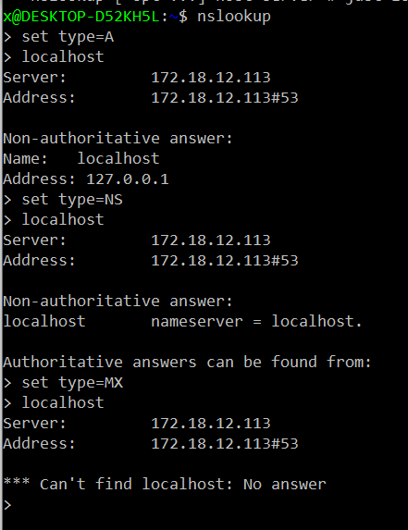

Type A shows the localhosts (my computer’s) IP address
Type NS shows the DNS name server for my localhost, which incidentally is also my localhost
Type MX shows details of the mail exchanger for my localhost, however my localhost doesn’t have a mail exchanger so nothing is shown.
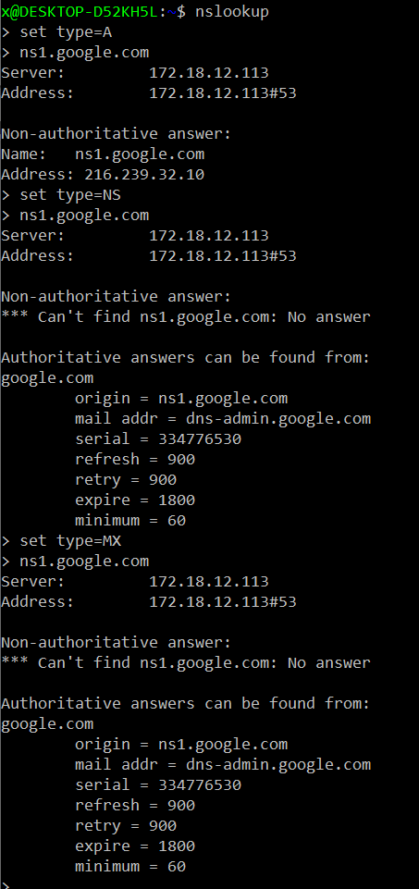
Type A shows the IP address of the DNS server
Type NS shows the details for the DNS name server for ns1.google.com
Type MX shows the mail exchanger details for ns1.google.com
Type NS and MX show the same details for ns1.google.com
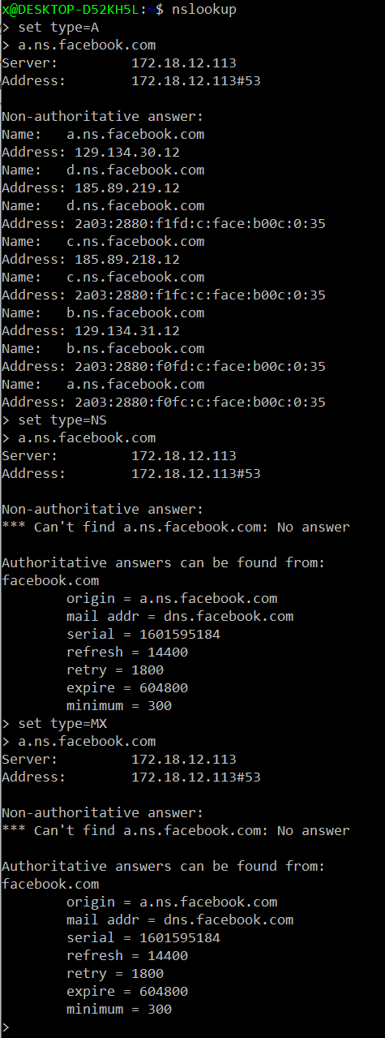
Type A shows the IP addresses of the DNS server
Type NS shows the details of the DNS name server for a.ns.facebook.com
Type MX shows the mail exchanger details for the a.ns.facebook.com
Type NS and MX show the same details

- Use nslookup to find a Web server that has multiple IP addresses. Does the Web server of your institution (school or company) have multiple IP addresses?
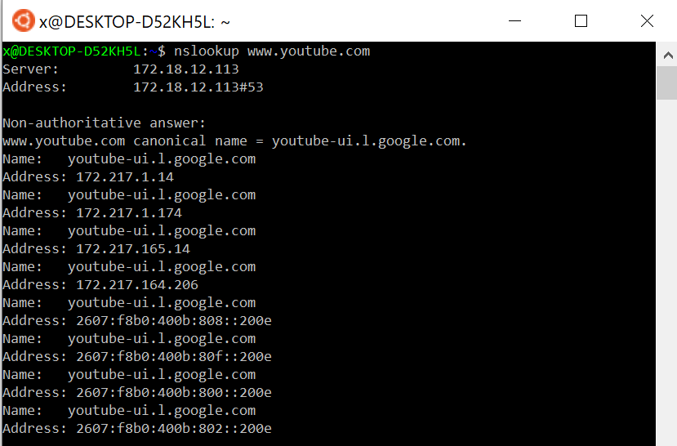
Looking up www.youtube.com, it can be seen that it has multiple web servers

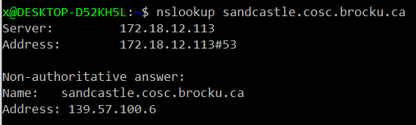
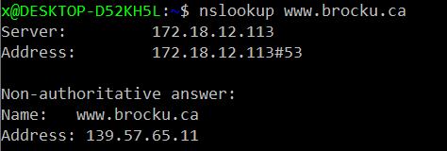
Both web servers of my institution do not have multiple IP only addresses, only one.
(www.brocku.ca and www.sandcastle.cosc.brocku.ca)

- Use the ARIN whois database to determine the IP address range used by your university.
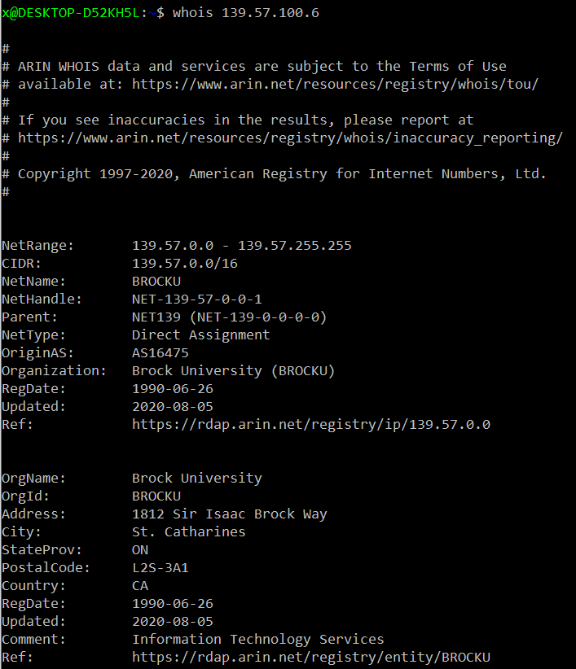
(For sandcastle.brocku.ca) Using the whois lookup tool to find the address range used by my University, it can be seen that the range is from 139.57.0.0 to 139.57.255.255 according to the ARIN database.

- Describe how an attacker can use whois databases and the nslookup tool to perform reconnaissance on an institution before launching an attack.
An attacker can use a whois database and the nslookup tool to find every Ip address used by that institution to know what IP addresses to target with an attack

- Discuss why whois databases should be publicly available.
Whois databases should be publicly available because of the useful information they contain, such as who registered a domain, the contact details for that registrar should someone need to get in touch with them, and can specifically be used by the public to check if a particular domain has already been registered in the event they wish to purchase it.

2.
- Running the command “dig @a.root-servers.net www.brocku.ca +norecurse”:
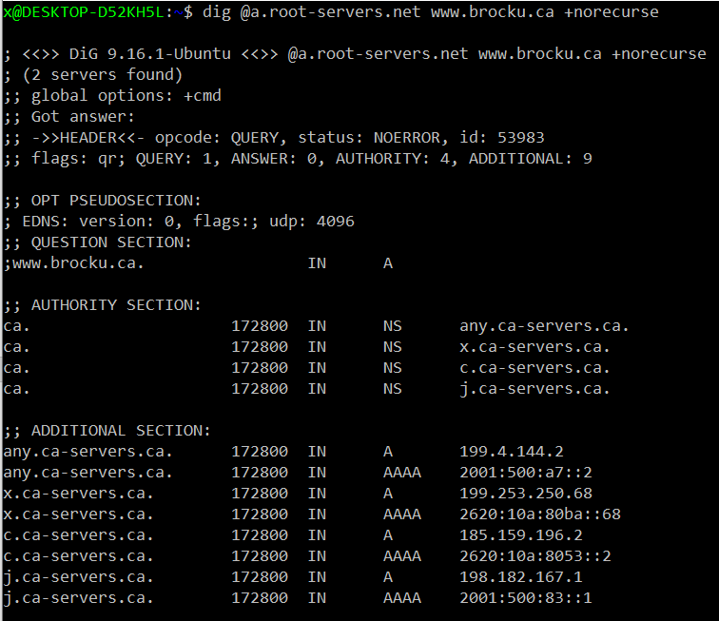
Send a query to first returned server in Authority section: Run “dig @any.ca-servers.ca www.brocku.ca +norecurse”:
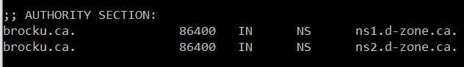
Send a query to the first server returned: Run “dig @ns1.d-zone.ca www.brocku.ca +norecurse”:
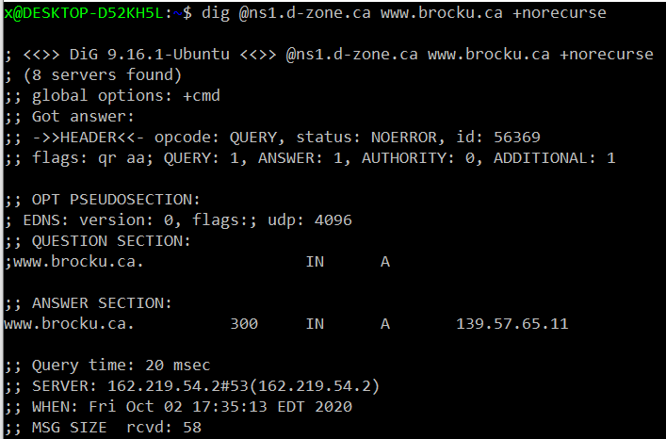
As we can see we reach www.brocku.ca at this point. Thus, the DNS server names in the delegation chain is:
- a.root-servers.net
- any.ca-servers.ca
- ns1.d-zone.ca

- Repeating the same process as (a) for google.com. Initial command: “dig @a.root-servers.net www.google.com +norecurse”
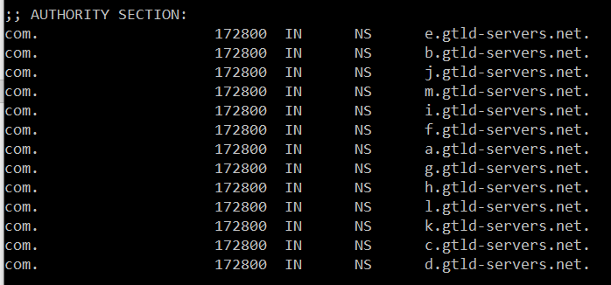
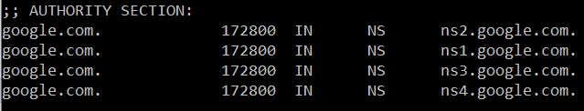
Thus the delegation chain is:
- a.root-servers.net
- e.gtld-servers.net
- ns2.google.com

Similarly for www.amazon.com. Initial command: “dig @a.root-servers.net www.google.com +norecurse”
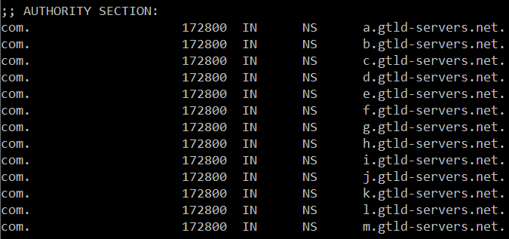
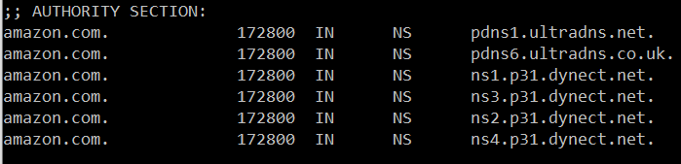
Delegation chain:
- a.root-servers.net
- a.gtld-servers.net
- pdns1.ultradns.net

3.1
- .
  - My browser is running HTTP version 1.1
  - The browser indicates to the server that it can accept only English (CA or US) as shown in the HTTP request “Accept-Language” header
  - The IP of my computer is 192.168.1.59 and the IP of the gaia.cs.umass.edu server is 128.119.245.12
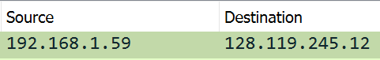
  - The status code returned from the server to the browser is 200 signalling an ‘OK’ message
  - The HTML file was last modified by the server on Saturday, October 3rd 2020 at 5:59 GMT according to the HTTP “Last-Modified” header
  - 128 bytes of content are being returned to the browser as shown in the HTTP “Content-Length” header
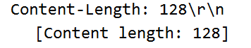
  - No there are no headers in the raw data that do not appear in the packet listing window.
- .
  - My browser sent 2 HTTP get requests as can be seen below, however only the first one is relevant to the document (Bill of Rights) requested.
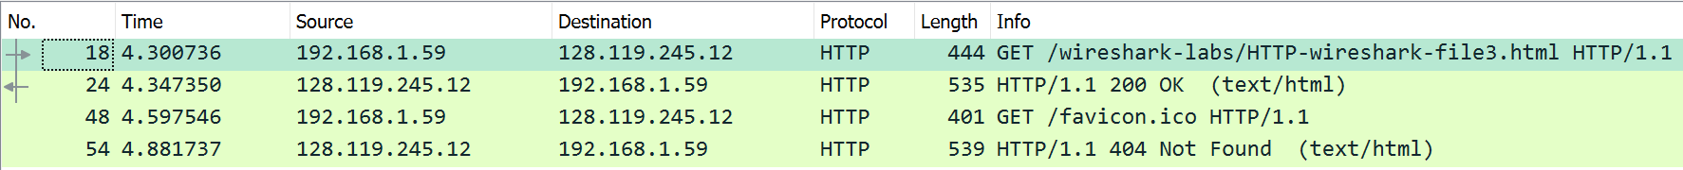
  - The packet number containing the status code and phrase associated with the response to the HTTP GET request is 24.
  - The status code in the response is 200 and the phrase is “OK”.
  - 3 data containing TCP segments were needed to carry the HTTP response and the text Bill of Rights.

3.2
- .
  - The DNS query and response messages are sent over UDP (User Datagram Protocol).
  - The destination port for the DNS query is 53 and the source port for the DNS query response is also 53.
  - The DNS query message is being sent to IP address 192.168.1.1. Using “ipconfig /all” I can see that the IP for my local DNS server is also 192.168.1.1 thus they are the same.
  - The DNS query is type AAAA and does not contain any answers.

  - There are no “answers” provided in the DNS query response.
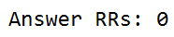
- .
  - The destination port for the DNS query is 53. The source port of the DNS response message is also 53.
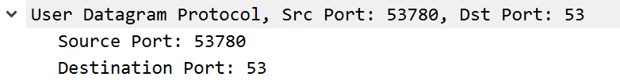
  - The DNS query is being sent to IP address 192.168.1.1, which is the IP address of my local DNS server
  - The query is type A and does not contain any answers.
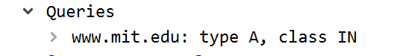

  - The DNS query response message contains 3 “answers”. Each of these answers contain the name, address type, class, time to live (TTL), length of data and canonical name/IP address (CNAME if type = CNAME, IP address if type = A/Host Address)


   
